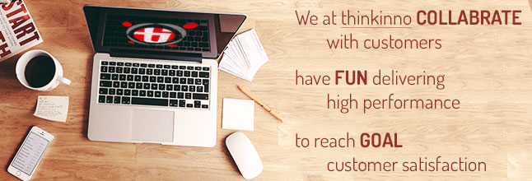

**About Thinkinno Technologies**

**Empowering Business Transformation**

Thinkinno Technologies is an Information Technology company which provides technology solutions to customers in North America and India. The company has provided software development solutions for various products in the Banking and Financial Service Industry (BFSI) in North America and also for custom business applications in India.

**Competencies:**

* Data Analytic s & Reporting
* Work-flow Competencies
* Elegant and creative site template development abilities
* Industry standards based deployment methodologies
* Abundant experience in design, development and maintenance of portals and e-commerce (B2B and B2C) sites
* Expertise in 3rd party applications integration with social networking tools
* Professional Design (Look and Feel, Usability)
* Comprehensive Functionality (Front-end Functionality, Back-office Administration)
* Back-end Programming (Dynamic page generation, Database design, development, encryption, Advanced search mechanism, Built-in security, Real-time payment processing)

**Questionnaire**

|  |  |
| --- | --- |
| **Contact Details** | |
| Company |  |
| Contact |  |
| Phone |  |
| Email |  |
| How did you hear about us / Thinkinno? | Google / Bing / Linked-in / Face-book /  Any other |
|  | |
| **What type of application would you like?** | |
| 1. Web Based (Yes / No) |  |
| 1. Mobile App (Yes / No) |  |
| 1. Mobile App Type  (Hybrid / Native) |  |
| 1. Mobile Native Type (Android / iOS / Both) |  |
| 1. Desktop Based App  (Yes / No) |  |
|  |  |
| **Tell us more about application / business requirement** | |
| 1. What would you like to build? (Please let us know in brief) | |
| Your Comments - | |
|  | |
| 1. Have you ever tried using a readymade application for the same requirement? If yes then please provide the name of an application? | |
| Name / Reference: | |
| Reason to discontinue: | |
|  | |
| 1. The application is required in how much time? Or how soon would you like to start using / selling the application? | |
| Your Comments - | |
|  | |
| 1. Are you aware that it would take more time to develop a customized application than to buy/rent a ready-made application? | |
| Your Comments - | |
|  | |
| 1. Are you aware about the below mentioned additional costs that may be incurred for an application to run (based on the requirements)?  Primary: Domain, Server Hosting, Database & Web Server licenses  Secondary: Payment Gateway Integration, Third Party Tools for Graphs, PDF, SMS Facility, Mapping Tool, Third Party Data etc. | |
| Your Comments - | |
|  | |
| 1. How soon would you to start the development?  (Weeks / Months) | |
| Your Comments - | |
|  | |
| 1. Estimated Budget (INR) | |
| Your Comments - | |
|  | |
|  | |
| 1. Would you like to use it for your business purpose OR you would like to offer this Software as a services (SAAS) to be used by your clients? | |
| Your Comments: | |

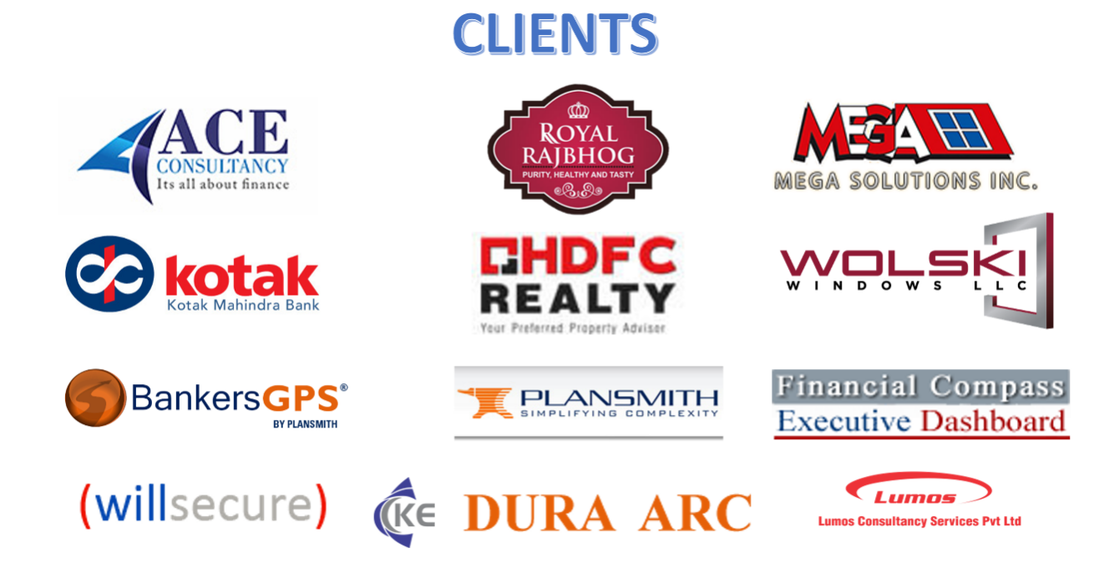

**Testimonial for Thinkinno**

For more information about how client describe our service please follow the link

<https://www.thinkinno.com/testimonials/>

